Day 3 - API Integration Report – NIKE_UI

* API Integration Process :

Step 1: setup up sanity studio in project:

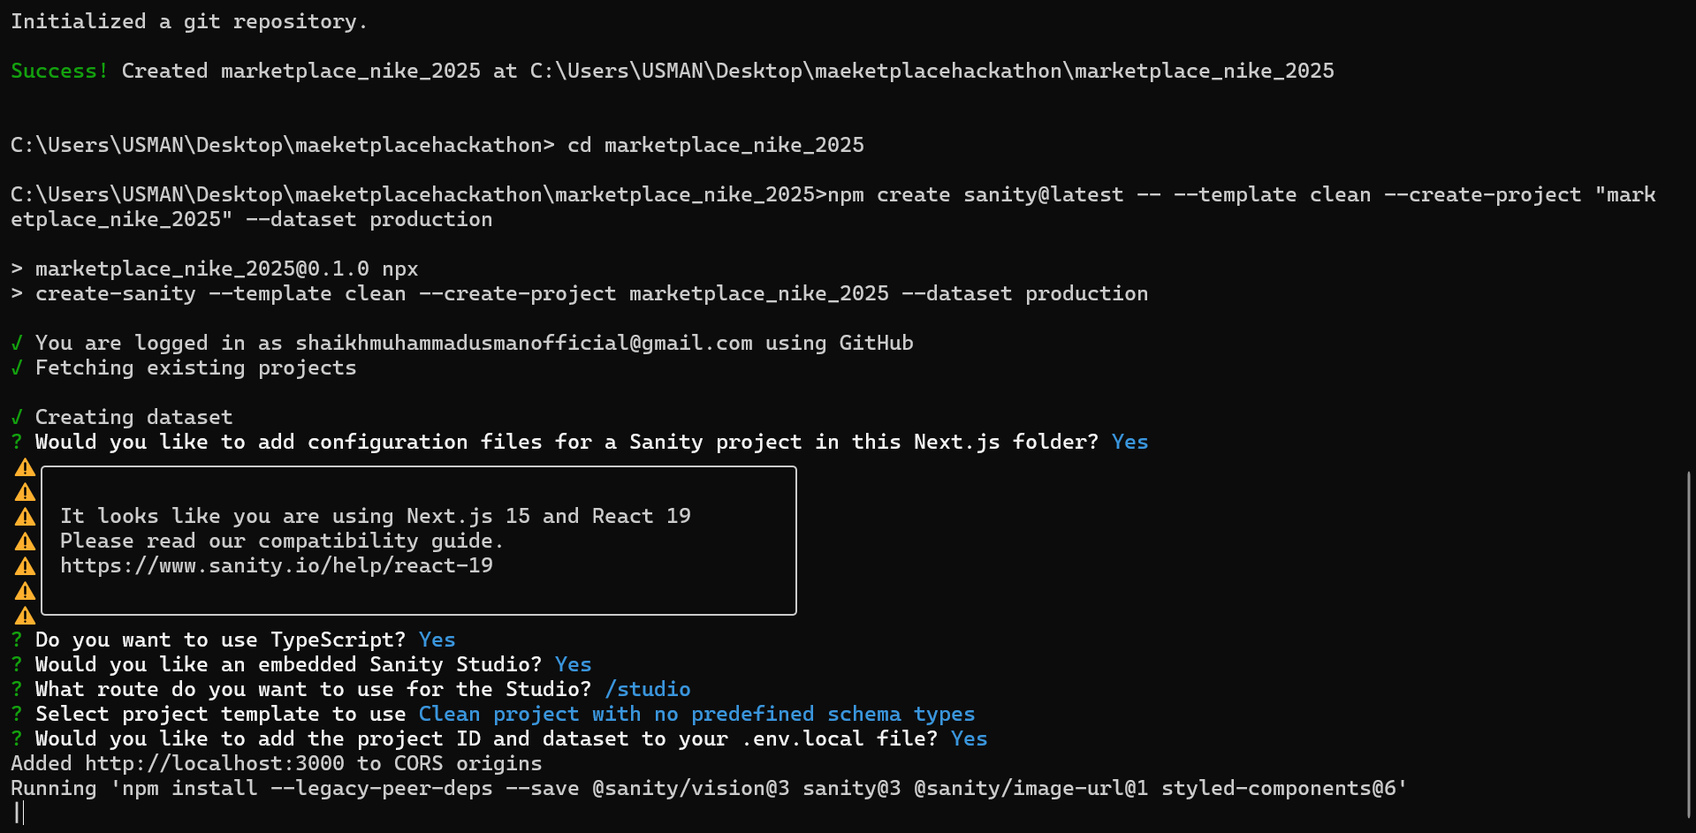

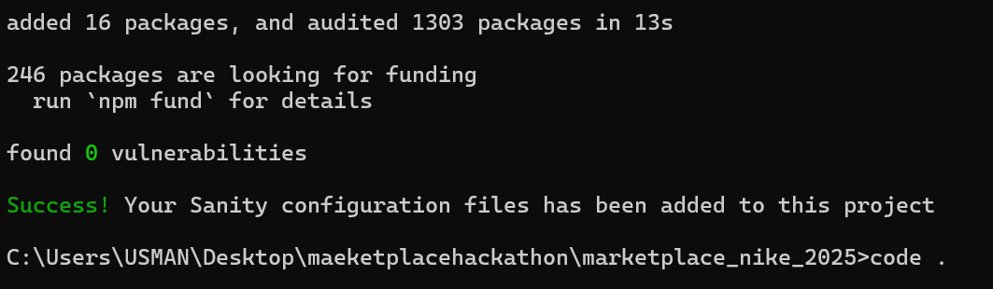

* Step2: Setting up sanity studio:

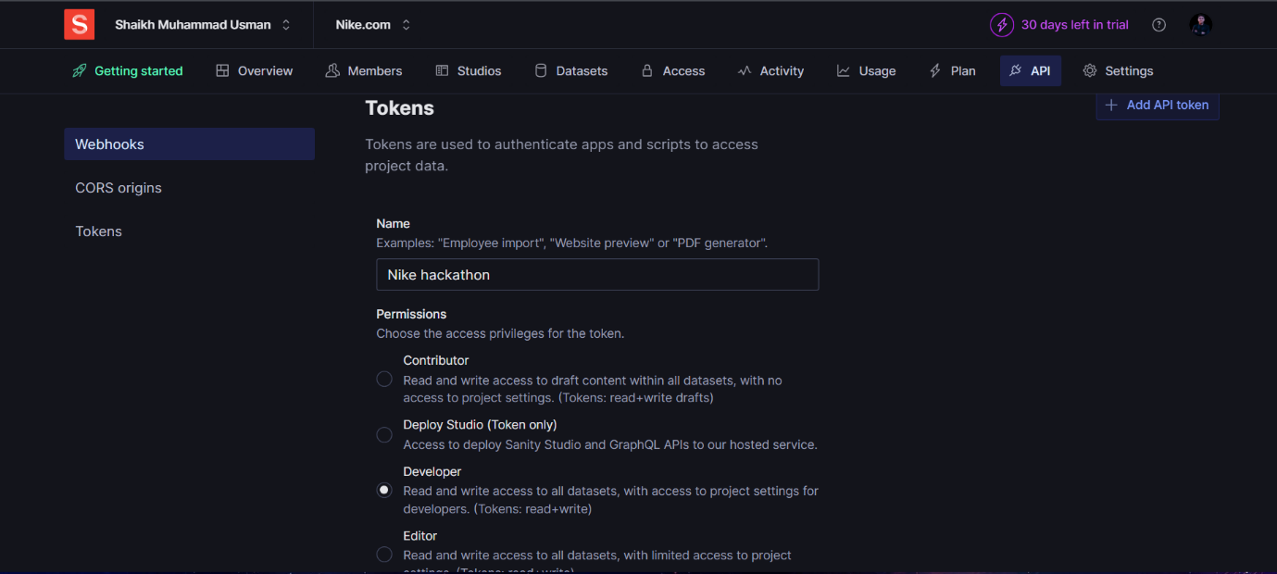

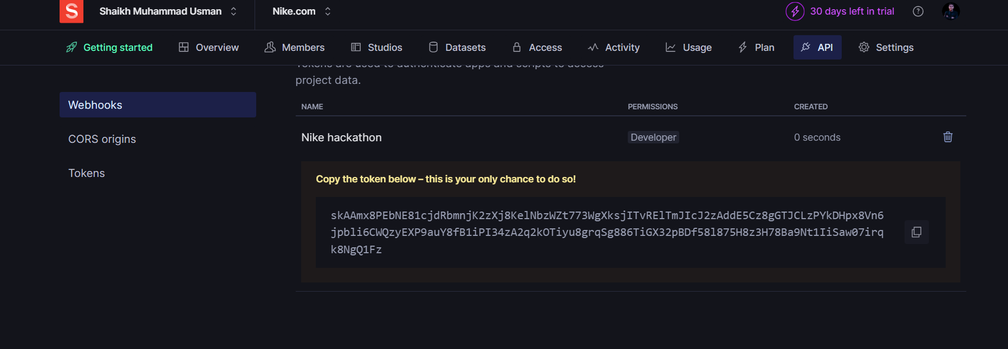

* Step3: API Integration

|  |  |
| --- | --- |
|  | Details |
| API Endpoint: | https://template-03-api.vercel.app/api/products |
| Libraries | Axios (for fetching products form the provided API) |
| Data Structure | The provided Api provides products for our Nike UI store. Each Products has its own:   1. Product Name 2. Product Category (since we have multiple) 3. Product Price 4. Product Inventory 5. Product color, 6. Product Status 7. Product description, and 8. Product image |

Fetch Data from API

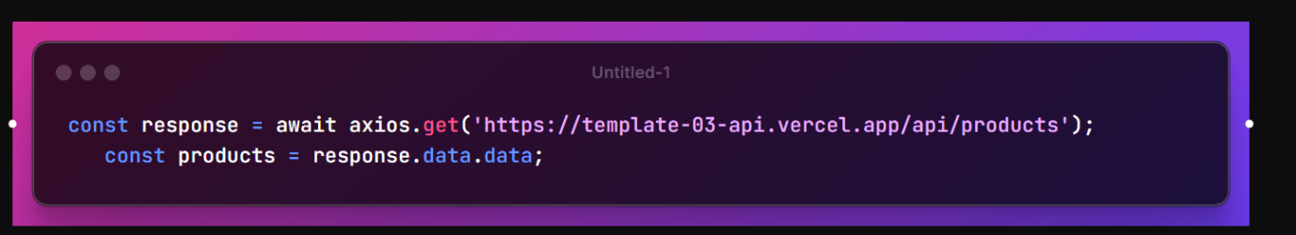

|  |  |
| --- | --- |
| MIGRATION TOOLs |  |
| @sanity/client | Uploaded images to Sanity's Asset Manager using the Sanity client. |
| axios | product data from the API  Downloaded images from the API's image field |
| dotenv | to load environment variables from “env.local” |

Code snippets:

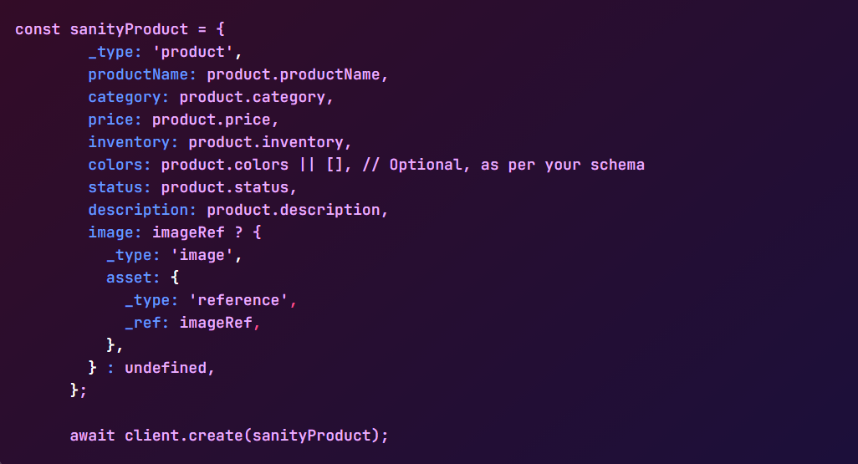

* API Call Output :

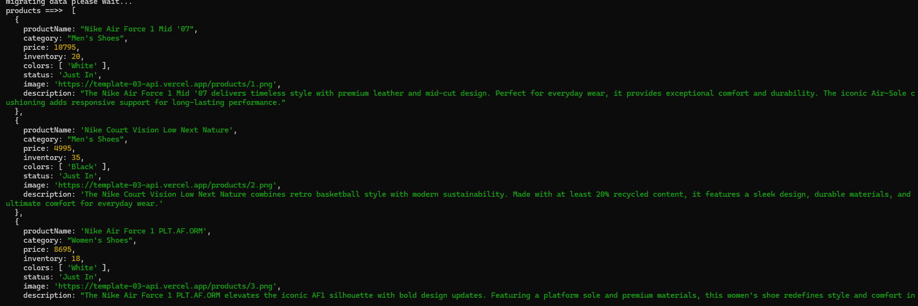

* Sanity product display:

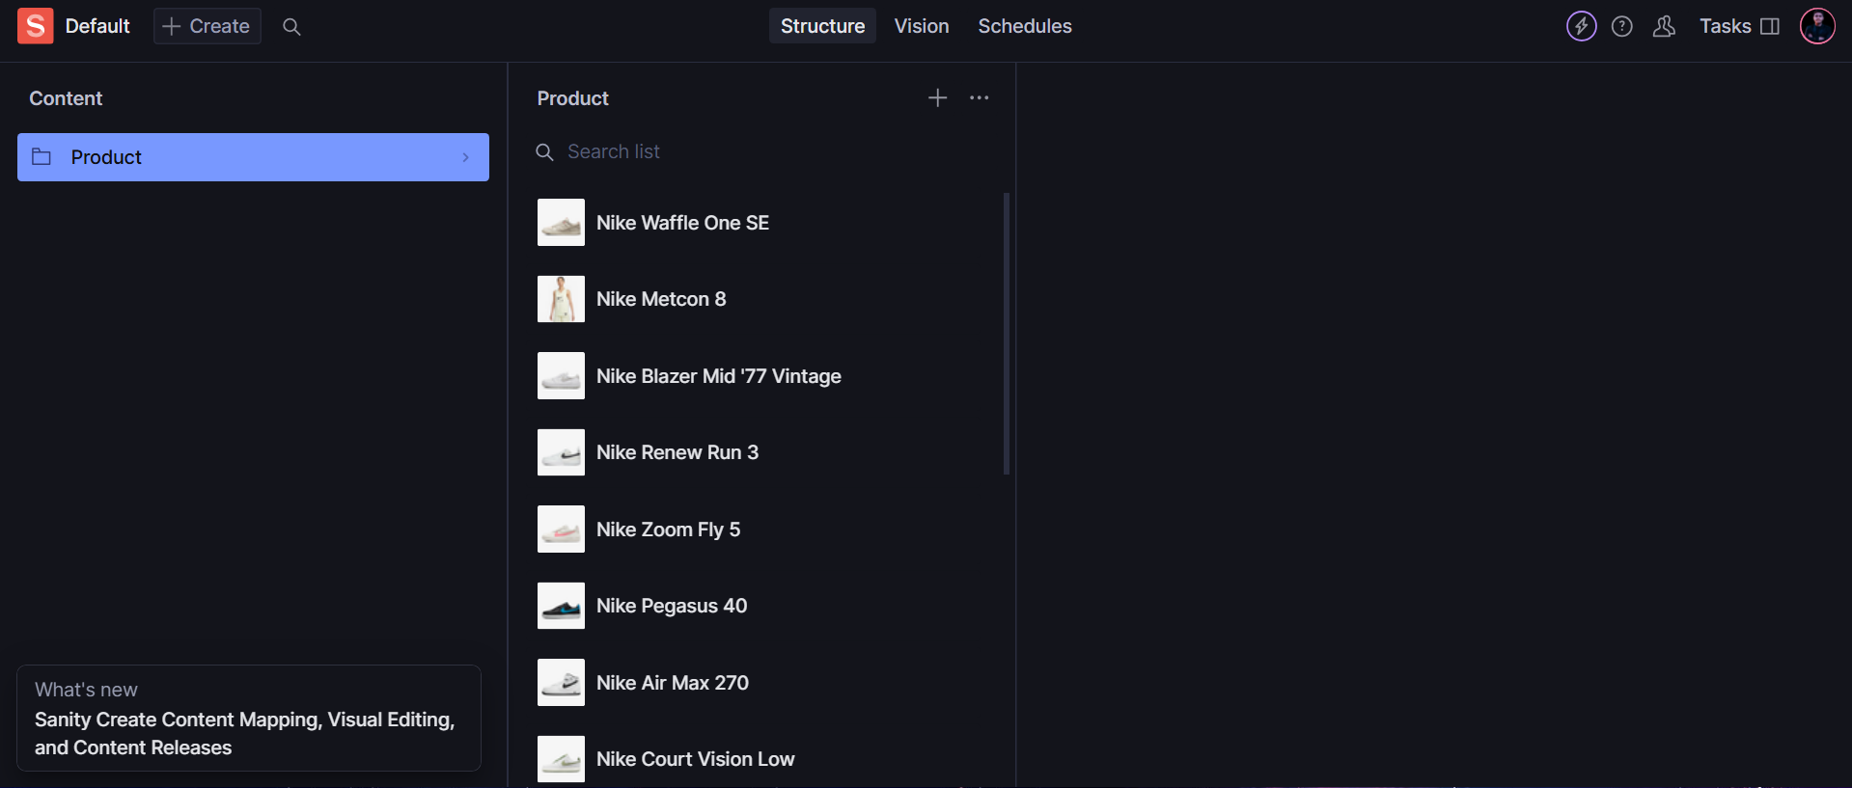

* Frontend Display :

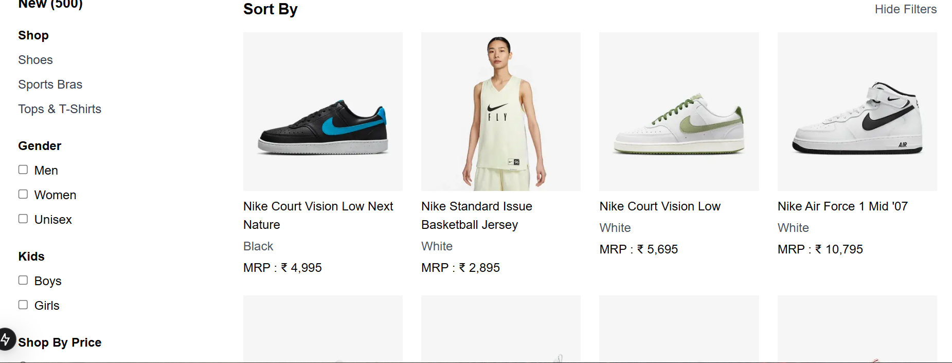

Day 3 checklist:

|  |  |
| --- | --- |
| API Understanding : | ☑ |
| Schema Validation | ☑ |
| Data Migration | ☑ |
| Submision Preparation | ☑ |